Case Study:
Cognizant Games Arena — Listing the games developed for different platforms!
Develop a pseudo front end application which would let the users help list and browse games developed for different platforms conveniently.
[Minimum Requirement] (Entry level)
— Use of Web API to fetch games details.
- Utilize Response Parameters:
[title, platform, score, genre, editors_choice ].
- Implement functionality to list games in a web page.
— Visually interactive responsive design listing all the games.
— Submit Screenshot, Source code & Instructions.
[Plus Point] (Intermediate)
— A feature to Search (via name).
— Implement Sort feature (to filter through ‘score’ in ascending and descending order).
[Extra Work] (Experienced / wizard)
— Implement feature to sort games based on platform.(List on PS games or any other platforms).
— Display and keep track of response Header X-RateLimit-Remaining / X-RateLimit-Limit.
— Add autocomplete feature to Search games conveniently.
— Custom elegant design, fonts and icons to make web app more user-friendly.
— You may add portfolio activity comprising awesome work you have done on web application(s).
— Use your imagination and add features which would make things easier for end users.
[Guide]
— Games API: http://starlord.hackerearth.com/cognizantinternal/gamesarena
— Ideal Frontend Stack:
- * Any of your favorite JS Framework: Javascript (Angular JS), jQuery, HTML, CSS.
- * Custom CSS, Good if you can work around Bootstrap or Material Design.
- * Optional: Typography, Subtle pattern, Custom Icons.
— PS: Application can be built with use of client-side scripting and need not require any backend.
— HTML5 Local Storage: http://html5demos.com/storage
— For icons and subtle texture:
- http://glyphsearch.com/
- http://subtlepatterns.com/thumbnail-view/
- http://codebeautify.org/jsonviewer
- http://www.flaticon.com/categories
[Wireframe MVP / Reference Structure]
Mockup image with instructions:
App Page I — Home page comprising list of games.
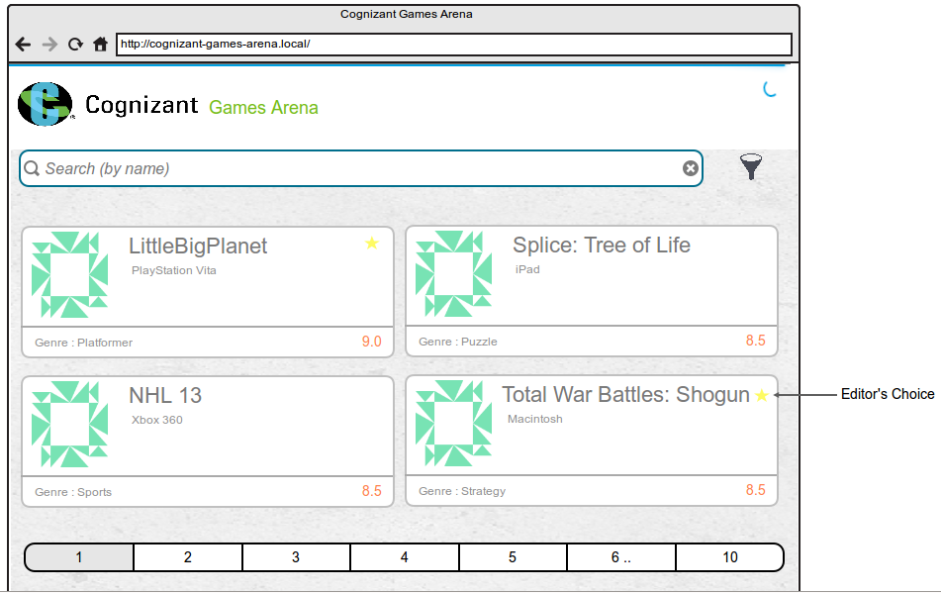
Note: Mockup design is just a reference made available to kick start the design process, you are free to come up with your own design, and we always admire creativity.
API Specs
API Status: https://hackerearth.0x10.info/api/uptime
- Supports GET/POST/PUT requests on HTTP as well as HTTPS.
- Output Response: JSON, CSV or XML
HTTP Header:
- access-control-allow-headers:Origin, X-Requested-With, Content-Type, Accept
- access-control-allow-methods:GET, POST, PUT
- access-control-allow-origin: *
- server: cloudflare-nginx
Structure / Data Parameters:
- title, platform, score, genre, editors_choice
- title — ‘title of the game’
- platform — name of the platform for which this game is designed.
- score — games rating score.
- genre — genre of the game.
- editors_choice — A value indicating whether this game was editor’s choice or not
Note : While executing the project, the root folder should have the file name as index.html. In case if you have used different file name or folder structure, then append the file name/folder path directly in URL while executing the project.
Example 1 :
http://digitaluniversity.cognizant.e-box.co.in:8080/deploy/1479214557302_1/filename.html
Example 2 :
http://digitaluniversity.cognizant.e-box.co.in:8080/deploy/1479214557302_1/folder_name/filename.html

